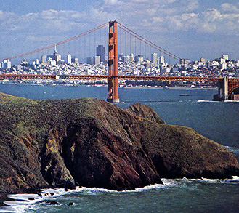
The City of San Francisco’s Department of Public Works had just received a huge amount of land from various people and organizations.

George Lucas had decided to move his company, LucasArts, down to Los Angeles, in hopes it will make him more successful. He has left his 300-acres in the Presidio to the city to do whatever they wish with it.

Then the Navy, due to too much lawsuit “mumbo-jumbo”, decided to close their Hunter’s Point Shipyard and donated the 100-acres of land to the city to use in any way they wanted to.

Finally, the 150 acres of land that the city had leased to the SF Zoo 99 years ago came to the end of the lease. Because the zoo has had so many protesters in the past 10 years about the condition of the animals’ lives at the zoo, they decided to close and move all the animals back to their natural habitats. This land became available to the city with no restrictions.

So that’s 550 acres of land that the city could use however they wanted. The problem was that, as you know, people in a city have many different opinions. The two biggest and most vocal groups had opposing views. One group wanted to use as much of the land as they could for development—that is, for stores, businesses, and housing. The other group wanted to use as much of the land as possible for recreation—that is, hiking trails, picnic areas, and park land.

After much deliberation and many City Council meetings, one conclusion was reached. The City Council agreed that at least 300 acres would be designated for development. The business-minded people were ecstatic—they saw this as a huge success!

The two groups also came to a compromise about the remaining land, as they both wanted their houses and parks on attractive land with nice views and surroundings. Their compromise said that at most 200 acres of the Naval Shipyard and the SF Zoo could go to recreation. In addition, the amount of Naval Shipyard land used for recreation and the amount of Presidio land used for development had to total exactly 100 acres.

The city manager made a chart of the costs for both development and recreation. The City of San Francisco wants to keep its cost to a minimum since it might be losing revenue because the 49ers are sell-outs and moving to Santa Clara!

Land | Improvement costs per acre for recreation | Improvement costs per acre for development
LucasArts—Presidio | $50 | $500
Shipyard—Hunter’s Point | $200 | $2000
SF Zoo—Golden Gate Park | $100 | $1000

The city manager had the exciting job of deciding how to split the land so that the cost to the city was minimized, but also so all of the conditions agreed on by the city council were met. She had no idea how to do this, so she called me up and I said my students would be happy to help her out! ☺

