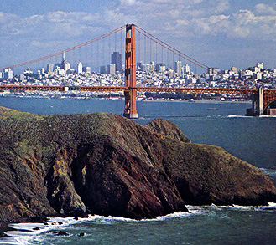

The Basic Story:
- Describe the three pieces of land that have been given to the city of San Francisco (how much land and by whom was it donated?)

- What are the two ways that the land will eventually be used?

- What are the conclusions that the groups and city council came to?

From Story to Math:

- Using the variables defined, write the constraints that are described in the story.

I._____________________________________ Variables Defined
LR = acres of Lucas land for recreation
II._____________________________________ NR = acres of Naval land for recreation
ZR = acres of Zoo land for recreation
III._____________________________________ LD = acres of Lucas land for development
ND = acres of Naval land for development
IV._____________________________________ ZD = acres of Zoo land for development

V._____________________________________

VI._____________________________________

VII._____________________________________ X._____________________________________

VIII._____________________________________ XI.____________________________________

IX._____________________________________ XII.___________________________________

(If you are having trouble finding the all 12 constraints, remember that this is a real life situation so what must be true about each variable?)
- Use the variables to write an algebraic expression for the city’s cost based on how the land is allocated.

City’s Cost = _________________________________________________________

- Check whether the following allocations satisfy the constraints. If it does, find the cost to the city. If it does not, show which constraint(s) it violates.
  - LR = 250 b. LR = 200
NR = 50 NR = 0
ZR = 150 ZR = 0
LD = 50 LD = 100
ND = 50 ND = 100
ZD = 0 ZD = 150

