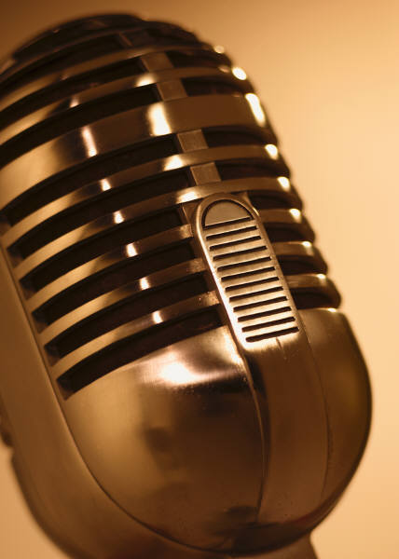
The Radio Project
City Arts & Tech High School
May 18, 2006

In this workshop, students had the opportunity to express their opinions and answer the question: Does history repeat itself? through writing and recording an audio commentary. They researched historical or present-day events, examined the roles of upstanders and bystanders and related their analyses to the Holocaust. In addition, they created unique silhouettes with direct quotes from their commentaries. Their recordings and visual pieces will be broadcast and displayed tonight. Enjoy!

Solar Students: Room 107

Group 1: 6:40 – 7:10
Aaron Alvarez
Cameron Gordon
Eva Yip
Louis Yashuhiro
Gull Schneider
Dominick Davis
Ian Mobley
Evan Hennessey

Group 2: 7:15 – 7:45
Ariel Bott
Markeda Cottonham
John Carreon
Lucas Wade
Jordan Saucier
Dejon Sandefur
Adrianna Valle
Steven Camozzi

Group 3: 7:50 – 8:20
Julia Nenaydokh
Jasmin Palencia
Keenan Henry
Isaac Roller
Derick Dragon
Timothy Lai
Ilisha Graham

Lunar Students: Room 206

Group 1: 6:40 – 7:10
Alexandria Cordova
Owen Delay
Dakarai Griffin
Remi Harris
Alma Herrera
Wolfgang Welch
Aryana Wills

Group 2: 7:15 – 7:45
Myrna Barrera
Ashley Duran-Colburn
Andre Howard
Justin Kwok
Ramzi Nijem
Rathapoom Payasom
Mager Webb
Tiffany Zhang

THANK YOU
Youth Radio
Noel Benoza
Supporting CAT Staff
Group 3: 7:50 – 8:20
Zaid Anwar
Starkeisha Bailey
Navida Banderas
Giovanni Croppi
Hiroshi Kurakata
Reem Nijem
Sean Scheframek
Lucas Setefano

