A Correspondence between
History and My-Story

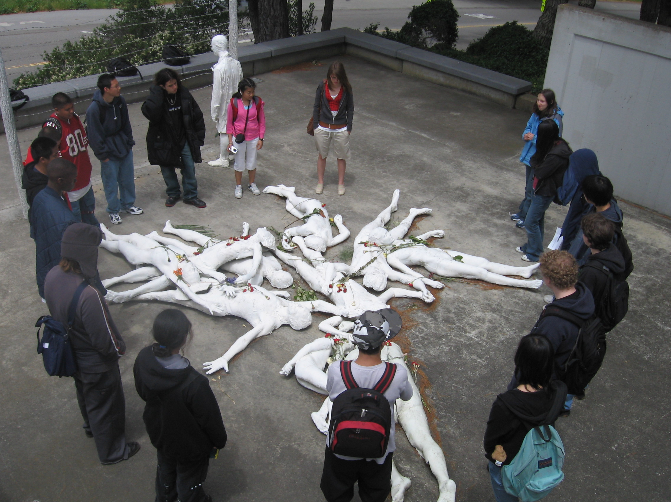

CAT Museum Exhibition May 2006

As Curators of this Exhibit, students were assigned to share their Testimony with the rest of the community. They used their artistic abilities alongside their writing skills to convey their understandings of the relationships betweens the past, the present, and future possibilities. Using more than one medium to express their ideas, students were asked to consider what they are a witness to, and how they are messengers. They have created their own personal narratives to guide you along their journey with them.
A Correspondence between
History and My-Story

CAT Museum Exhibition May 2006

As Curators of this Exhibit, students were assigned to share their Testimony with the rest of the community. They used their artistic abilities alongside their writing skills to convey their understandings of the relationships betweens the past, the present, and future possibilities. Using more than one medium to express their ideas, students were asked to consider what they are a witness to, and how they are messengers. They have created their own personal narratives to guide you along their journey with them.
Exhibit Times to meet the Author-Artists in Room 208

Showing I  (6:40-7:10) | Showing II  (7:15-7:45) | Showing III  (7:50-8:20)
Sarah Jane Calub  Rolando Casella  Jovan Gonyeau  John Jiminez  Tatyana Kulchinskaya  Sierra Laiafa  Tyler Leefeldt  Jonathan Lo  Peter Luc  Fia Samzelius  Felicia Turner  Julian Velasquez  Keith Ward  Craig Washington  Maria Zaragoza | Andrew Allio  Rolando Casella  Logan Fagalnafin  Debbie Irawan  John Jimenez  Tatyana Kulchinskaya  Katherine Law  Tyler Leefeldt  Peter Luc  Darian Ng  Brian Norte  John Sy  Felicia Turner  Julian Velasquez  Keith Ward | Andrew Allio  Sarah Jane Calub  Logan Fagalnifin  Jovan Gonyeau  Debbie Irawan  Sierra Laiafa  Katherine Law  Jonathan Lo  Darian Ng  Brian Norte  Fia Samzelius  Sydney Shoals  John Sy  Craig Washington  Maria Zaragoza

We encourage you to ask them some of the following questions:
- What is the message of your project and why it is important?
- What are the techniques and styles you used to create the project to ‘deliver’ the message?
- Explain your creative process and purpose for the various artifacts and writing samples.
- Why did you choose this format?
- What is the story or narrative behind your project?
- How is this project related to or relevant to you?
- How did this project extend your knowledge of the Holocaust and WWII?
- How does your work connect with the present and with the future?
Exhibit Times to meet the Author-Artists in Room 208

Showing I  (6:40-7:10) | Showing II  (7:15-7:45) | Showing III  (7:50-8:20)
Sarah Jane Calub  Rolando Casella  Jovan Gonyeau  John Jiminez  Tatyana Kulchinskaya  Sierra Laiafa  Tyler Leefeldt  Jonathan Lo  Peter Luc  Fia Samzelius  Felicia Turner  Julian Velasquez  Keith Ward  Craig Washington  Maria Zaragoza | Andrew Allio  Rolando Casella  Logan Fagalnafin  Debbie Irawan  John Jimenez  Tatyana Kulchinskaya  Katherine Law  Tyler Leefeldt  Peter Luc  Darian Ng  Brian Norte  John Sy  Felicia Turner  Julian Velasquez  Keith Ward | Andrew Allio  Sarah Jane Calub  Logan Fagalnifin  Jovan Gonyeau  Debbie Irawan  Sierra Laiafa  Katherine Law  Jonathan Lo  Darian Ng  Brian Norte  Fia Samzelius  Sydney Shoals  John Sy  Craig Washington  Maria Zaragoza

We encourage you to ask them some of the following questions:
- What is the message of your project and why it is important?
- What are the techniques and styles you used to create the project to ‘deliver’ the message?
- Explain your creative process and purpose for the various artifacts and writing samples.
- Why did you choose this format?
- What is the story or narrative behind your project?
- How is this project related to or relevant to you?
- How did this project extend your knowledge of the Holocaust and WWII?
- How does your work connect with the present and with the future?

